Claude Certification — Building with the Claude API
Section 7 — Features of Claude
Contents
- Lesson 1 — Extended Thinking

Lesson 1 — Extended Thinking

Core idea
Extended thinking is Claude's advanced reasoning feature: it gives the model time to work through a complex problem before writing the final answer. Think of it as Claude's “scratch paper” — you can see the reasoning process that leads to the answer, which helps with transparency and often improves response quality.

How It Works
With thinking enabled, the assistant message changes from a single text block into a structured response with two parts: a thinking block (the reasoning process) and a text block (the final answer). The diagram below shows the same recursion example: the user message is unchanged, but the assistant now returns a thinking block before the text block.
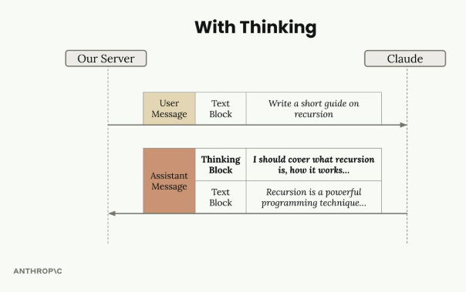
With extended thinking enabled, the assistant message contains a Thinking Block followed by the final Text Block.

Benefits
- Better reasoning — improved capability on complex tasks.
- Higher accuracy — on difficult problems where standard prompting falls short.
- Transparency — visibility into Claude's thought process.

Trade-offs
- Higher cost — thinking tokens are billed.
- Increased latency — thinking takes time before the final answer arrives.
- More complex response handling — code must handle the extra block type.

When to Use Extended Thinking
The decision is driven by evaluation results, not intuition: run prompts without thinking first, and if accuracy isn't meeting requirements after the prompt has already been optimized, then consider enabling extended thinking. It's a tool for when standard prompting isn't quite getting you there — not a default to switch on for every request.

The Signature: Response Security
Extended thinking responses include a signature field — a cryptographic token tied to the exact thinking text Claude generated. It verifies that the thinking content wasn't modified before being sent back to the API, preventing a developer from tampering with Claude's reasoning process in a way that could steer the model in unsafe directions.
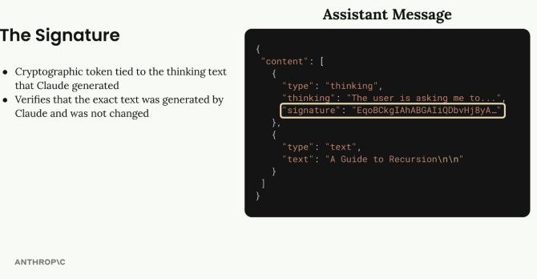
The signature field inside the thinking block is a cryptographic token tied to the exact reasoning text — it must be passed back unchanged.

Redacted Thinking
Sometimes, instead of readable reasoning text, the API returns a redacted_thinking block. This happens when Claude's internal reasoning gets flagged by safety systems. The block still contains the actual thinking, but encrypted, so the full message can be passed back to Claude in later turns without losing context. For testing, a special trigger string can be sent as the prompt to force a redacted thinking block, so an application's handling of this case can be verified without waiting for a real flag.

Implementation
Enabling extended thinking takes two new parameters on the chat function: a thinking flag and a thinking_budget (the max tokens Claude may use for reasoning, minimum 1024). The max_tokens parameter must be set higher than the thinking budget.
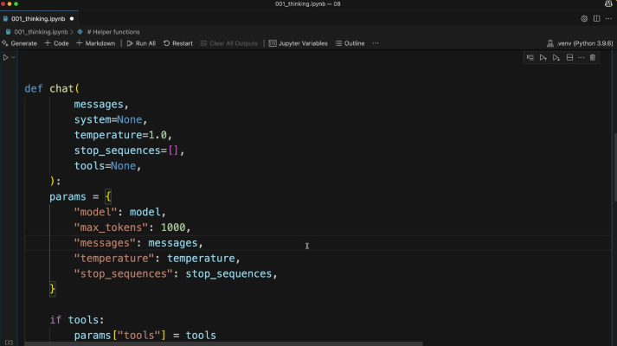
The chat() helper function that gets extended with thinking and thinking_budget parameters.
def chat(
messages,
system=None,
temperature=1.0,
stop_sequences=[],
tools=None,
thinking=False,
thinking_budget=1024
):
The thinking configuration is only added to the request parameters when thinking is turned on:
if thinking:
params["thinking"] = {
"type": "enabled",
"budget": thinking_budget
}
Calling it is then a matter of passing the flag:
chat(messages, thinking=True)

Practice Questions — Lesson 1
Choose the single best answer for each question (A–E).
1. What is extended thinking best described as?
A) A way to fine-tune Claude on custom data
B) A feature that gives Claude time to reason through a problem before the final answer, shown as a separate thinking block
C) A tool that lets Claude browse the web
D) A caching mechanism for repeated prompts
E) A way to reduce the number of tokens in a response
2. Which of the following is NOT listed as a benefit of extended thinking?
A) Better reasoning on complex tasks
B) Increased accuracy on difficult problems
C) Transparency into Claude's thought process
D) Lower latency on every request
E) Often results in higher quality responses
3. According to the lesson, when should a developer consider enabling extended thinking?
A) On every single API call, by default
B) Only for creative writing tasks
C) After running prompt evaluations without thinking and finding accuracy still isn't sufficient once the prompt is already optimized
D) Only when the user explicitly types "think" in the prompt
E) Never — it should be avoided in production
4. What does the signature field in a thinking block verify?
A) That the user's API key is valid
B) That the model used was Claude 4
C) That the thinking text is exactly what Claude generated and was not modified
D) That the response fits within max_tokens
E) That the thinking block was translated correctly
5. What triggers a redacted_thinking block instead of a normal thinking block?
A) The thinking_budget is set too low
B) The user asks a factual question
C) Claude's internal reasoning gets flagged by safety systems
D) The max_tokens parameter is missing
E) The request does not include any tools
6. In the redacted_thinking case, what happens to the underlying reasoning content?
A) It is permanently deleted and cannot be reused
B) It is kept in encrypted form so it can be passed back to Claude without losing context
C) It is shown to the developer but hidden from the end user
D) It is converted into a normal text block automatically
E) It is replaced with a generic placeholder message with no relation to the original reasoning

